Experiment No : 6
Apply K-Means and Hierarchical Clustering on sample datasets

1. Dataset Source
The dataset used for this experiment is a store customer's dataset.
SourceLink: https://www.kaggle.com/datasets/hosseinbadrnezhad/mall-customer-segmentation-dataset
2. Dataset Description
The dataset contains information about customers visiting a store and is used for segmentation.
- Number of Instances: ~200 (depends on dataset)
- Number of Features: 3–5

🔹 Features:
- Age → Customer age
- Annual Income → Income of customer
- Spending Score → Score assigned based on spending behavior

🔹 Target:
- No target variable (Unsupervised Learning)
- Goal: Group customers into clusters

3. Mathematical Formulation

🔹 K-Means
K-Means minimizes:
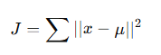
Where:
- x = data point
- μ = centroid

🔹 Hierarchical Clustering
- Uses distance matrix
- Builds tree-like structure (dendrogram)
Distance formula:
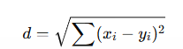

4. Algorithm Limitations

🔹 K-Means
- Need to choose K
- Sensitive to outliers

🔹 Hierarchical
- Slow for large data
- Hard to decide clusters

5. Methodology / Workflow
- Load dataset
- Select features (Income, Spending Score)
- Apply feature scaling
- Apply K-Means clustering
- Use Elbow Method
- Apply Hierarchical clustering
- Plot dendrogram
- Visualize clusters

6. Performance Analysis
- Clusters are evaluated visually
- K-Means gives clear grouping
- Hierarchical shows relationships

7. Hyperparameter Tuning
- K-Means → number of clusters (K)
- Hierarchical → linkage method
Code:
# ================= STEP 1: IMPORT =================
import numpy as np
import pandas as pd
import matplotlib.pyplot as plt

from sklearn.cluster import KMeans
from sklearn.preprocessing import StandardScaler
from scipy.cluster.hierarchy import dendrogram, linkage

# ================= STEP 2: LOAD DATA =================
df = pd.read_csv("store_customers.csv")

print("Dataset Preview:\n", df.head())
print("\nColumns:", df.columns)

# ================= STEP 3: HANDLE MISSING VALUES =================
df['Annual Income (k$)'] = df['Annual Income (k$)'].fillna(df['Annual Income (k$)'].mean())
df['Spending Score (1-100)'] = df['Spending Score (1-100)'].fillna(df['Spending Score (1-100)'].mean())

# ================= STEP 4: SELECT FEATURES =================
X = df[['Annual Income (k$)', 'Spending Score (1-100)']]

# ================= STEP 5: SCALING =================
scaler = StandardScaler()
X_scaled = scaler.fit_transform(X)

# ================= STEP 6: ELBOW METHOD =================
wcss = []

for i in range(1, 11):
kmeans = KMeans(n_clusters=i, random_state=42, n_init=10)
kmeans.fit(X_scaled)
wcss.append(kmeans.inertia_)

plt.plot(range(1,11), wcss, marker='o')
plt.title("Elbow Method")
plt.xlabel("K")
plt.ylabel("WCSS")
plt.show()

# ================= STEP 7: K-MEANS =================
kmeans = KMeans(n_clusters=5, random_state=42, n_init=10)
y_kmeans = kmeans.fit_predict(X_scaled)

plt.scatter(X_scaled[:,0], X_scaled[:,1], c=y_kmeans)
plt.title("K-Means Clustering")
plt.xlabel("Income")
plt.ylabel("Spending Score")
plt.show()

# ================= STEP 8: HIERARCHICAL =================
linked = linkage(X_scaled, method='ward')

plt.figure(figsize=(6,5))
dendrogram(linked)
plt.title("Dendrogram")
plt.show()

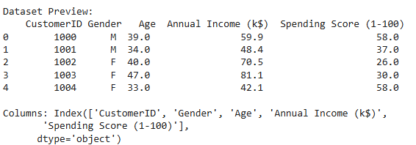
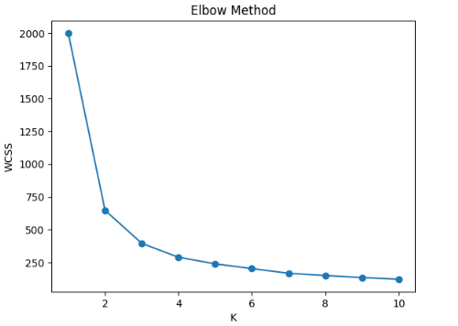

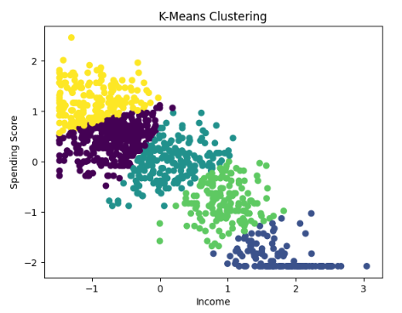
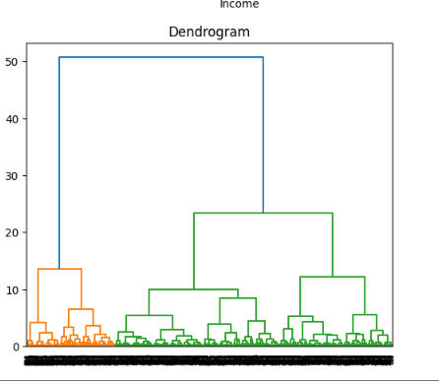

Conclusion:
In this experiment, K-Means and Hierarchical Clustering were successfully applied to the store customers dataset. K-Means efficiently grouped customers into distinct clusters, while Hierarchical Clustering provided a visual representation of cluster relationships using a dendrogram. These techniques are useful for customer segmentation and understanding patterns in data.

